https://www.databricks.com:- try data bricks
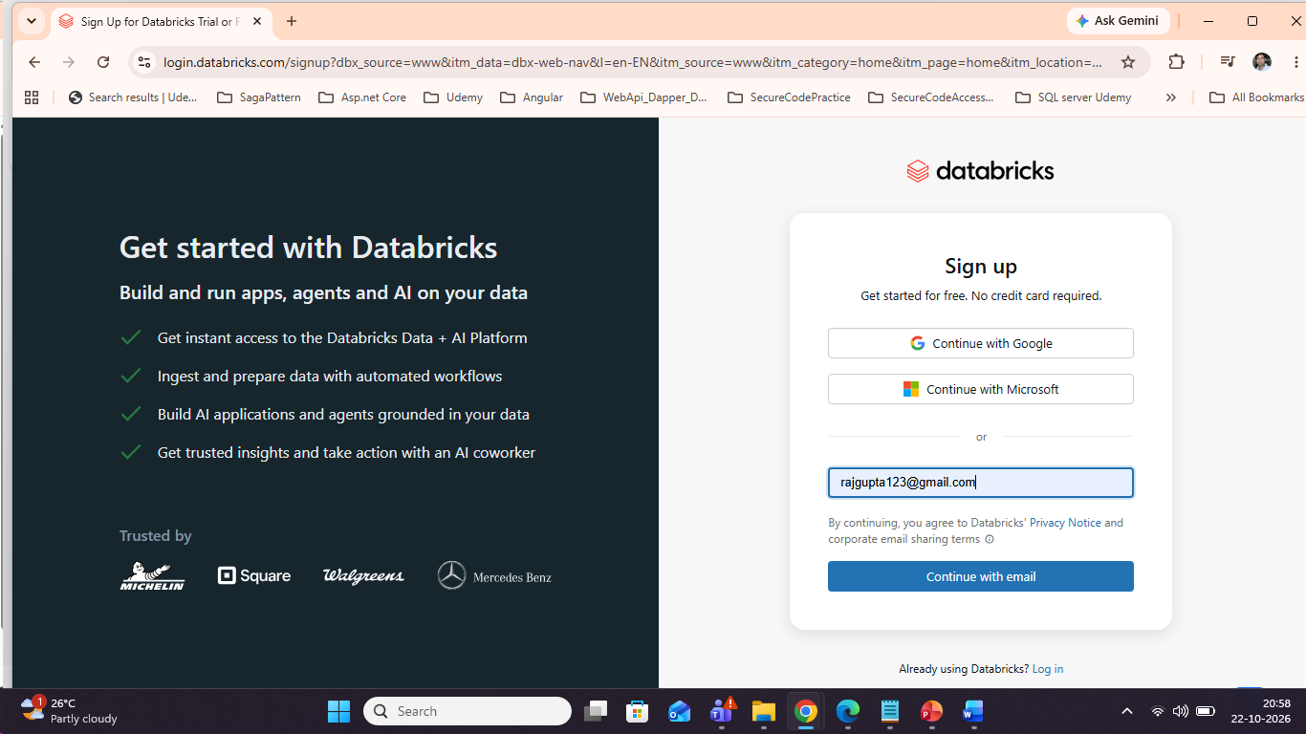
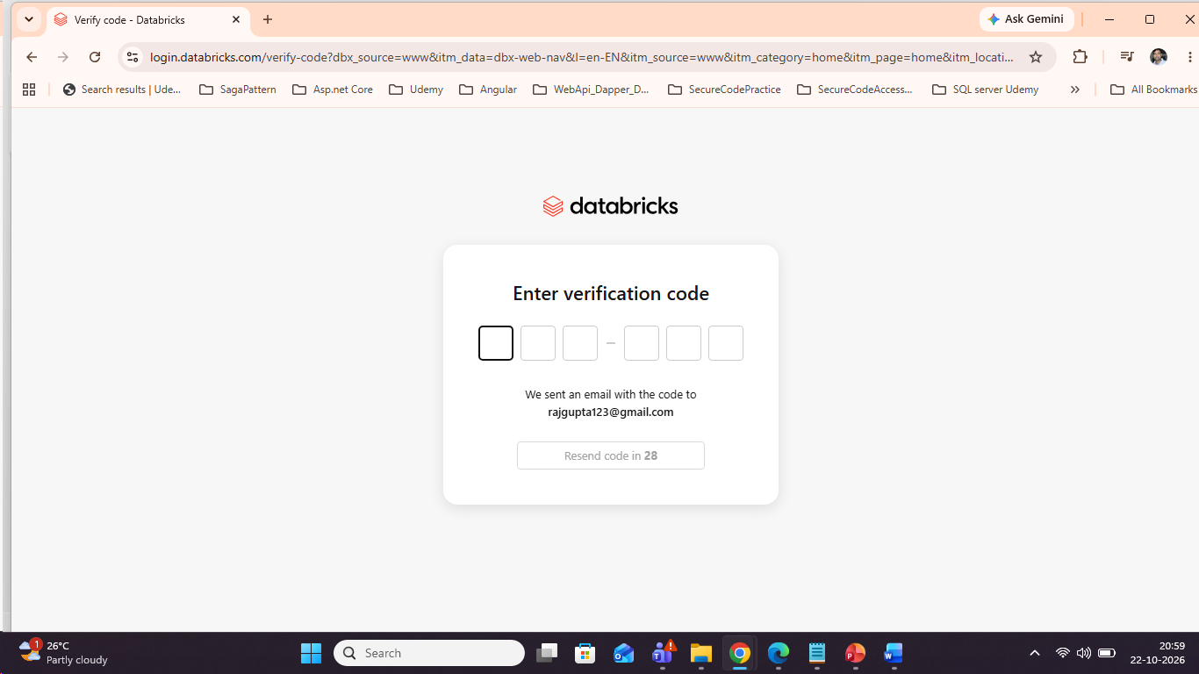
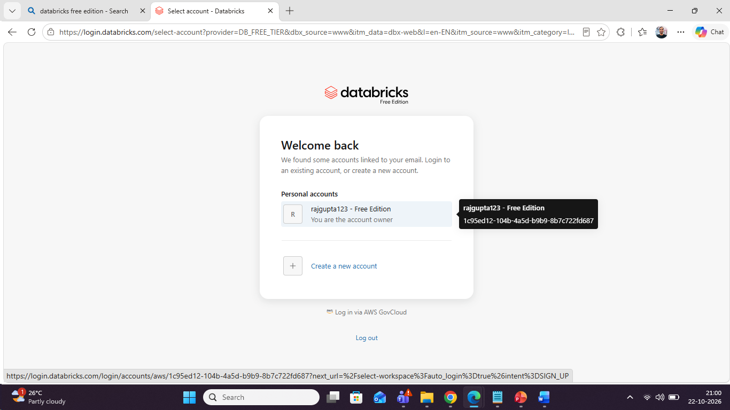
\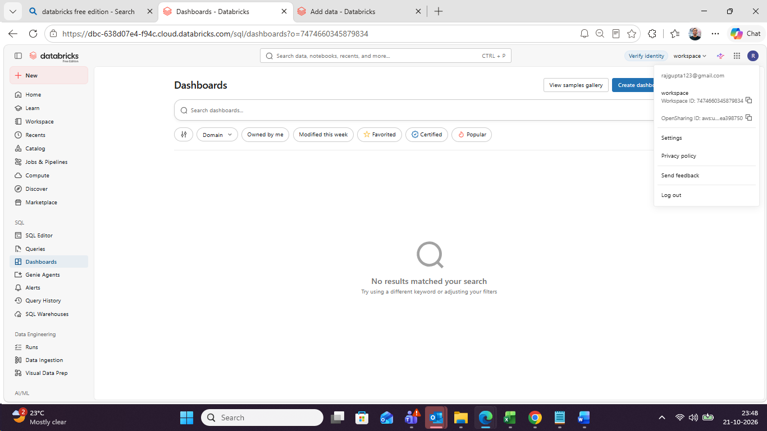
Steps:-
- Under workspace we have to do all kind of development .
- Under workspace we have user ,rajgupta123@gmail.com,under this you have to create all the kind of notebook ,write your pyspark code and you have to do all kind of development activity.
- In right hand side we have Create inside that show multiple options
- Inside Create-create a folder name Practical ,inside that we have to deo all kind of activity

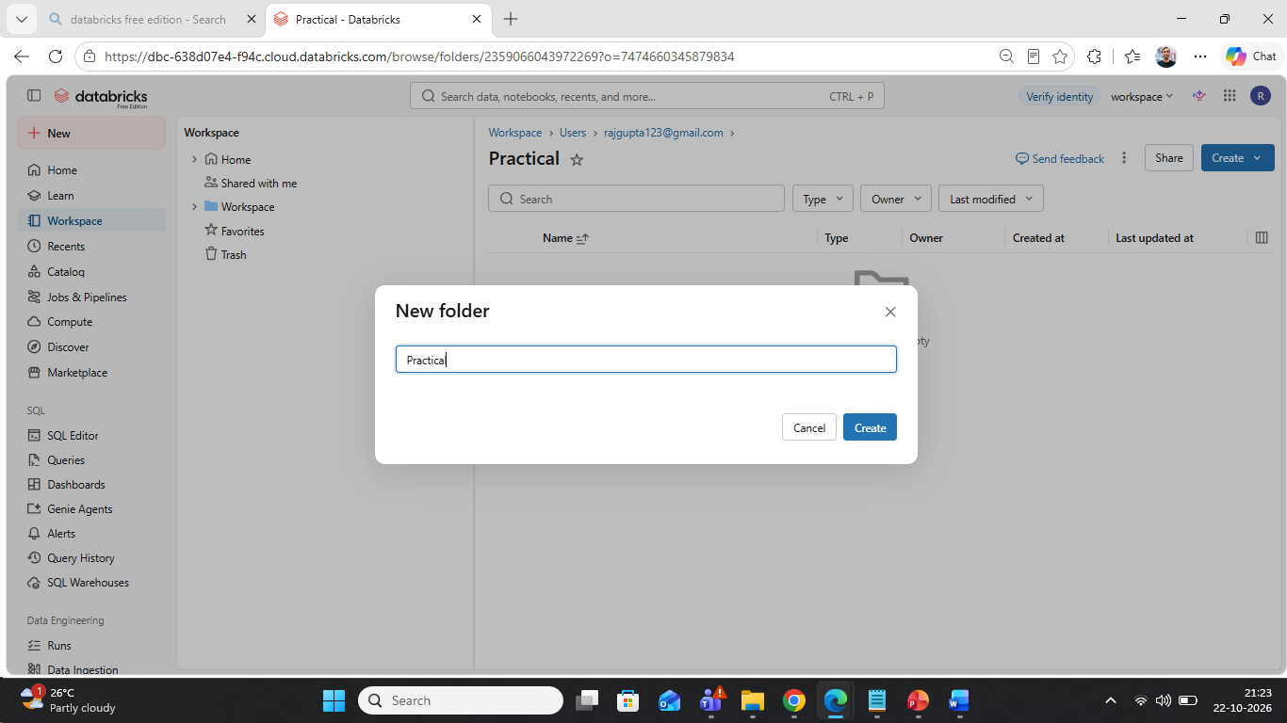
Inside the Practical folder create any type of notebook
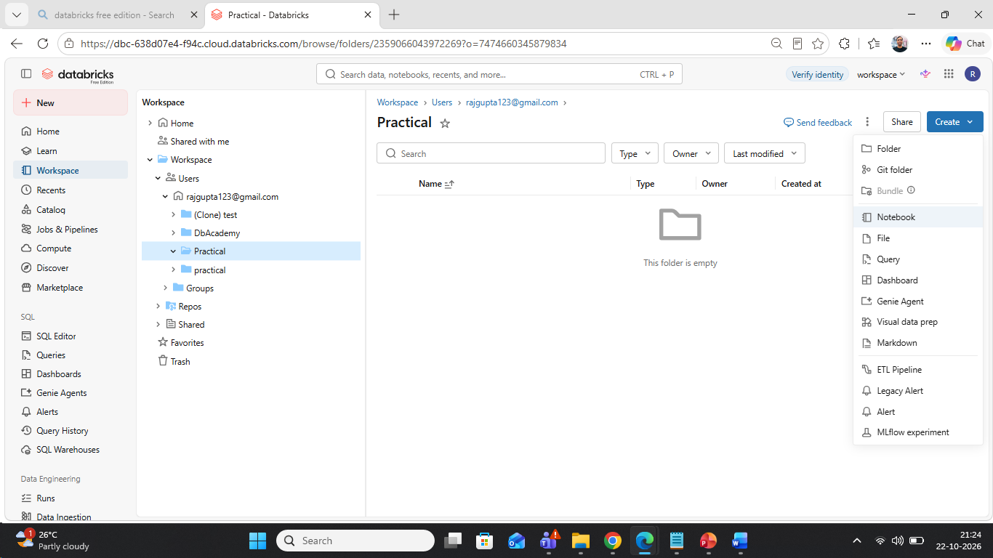
This notebook show just line Jupiter notebook in Python
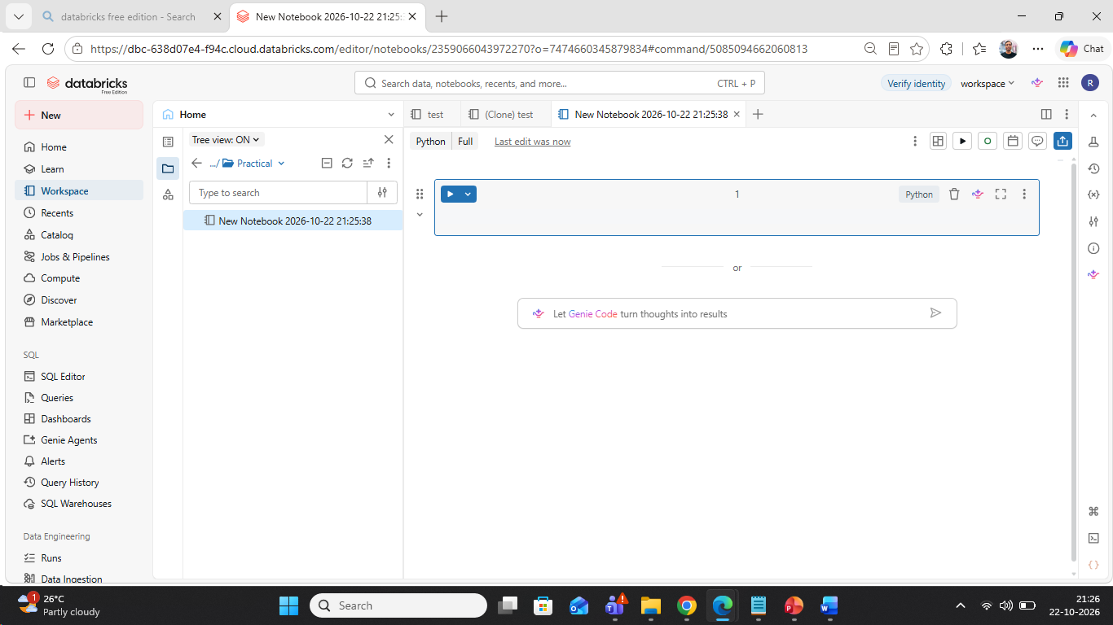
By default showing Python
If you want to run any code ,you need compute -right hand side show serverless
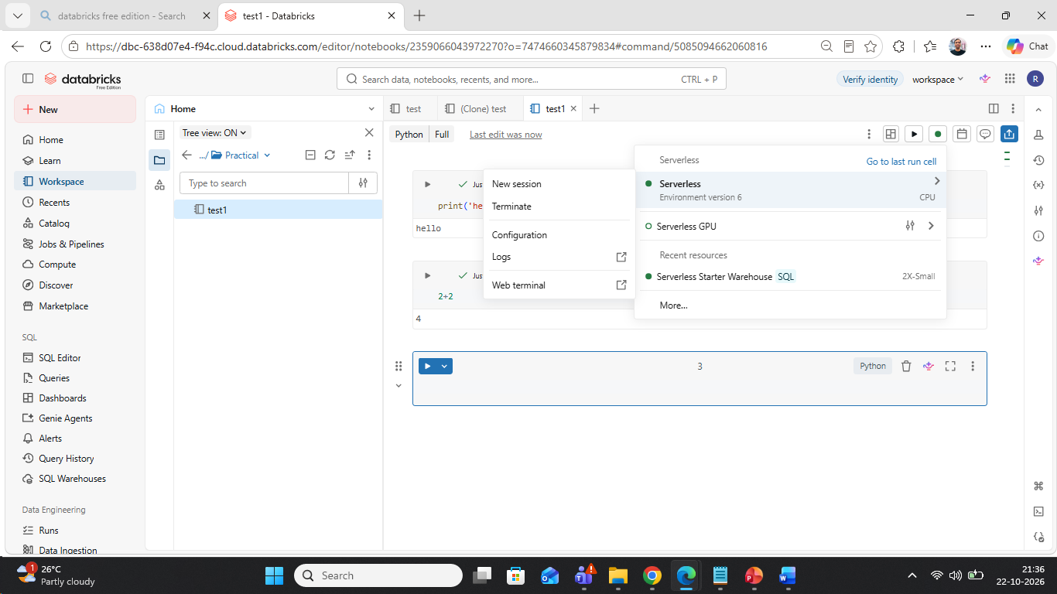
Serverless ->That is use for processing
In the free edition not possible to create any type of computation ,only we have serverless computation by default for processing
We have lots of option inside the notebook
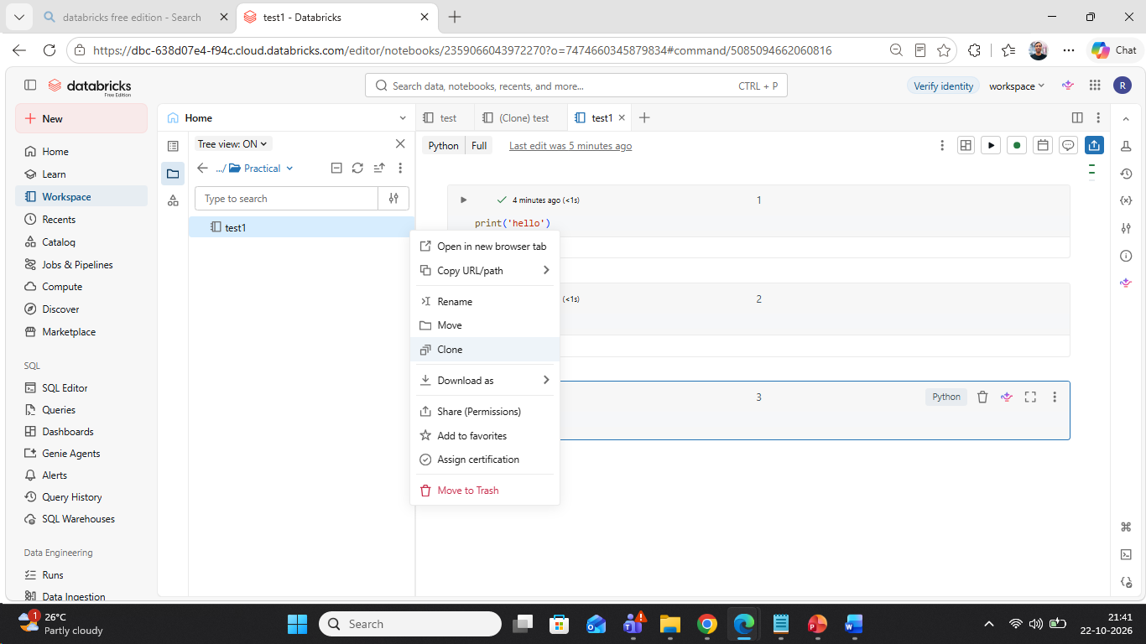
We have share (permission) we can share the notebook to the other user ,that user can access the notebook.
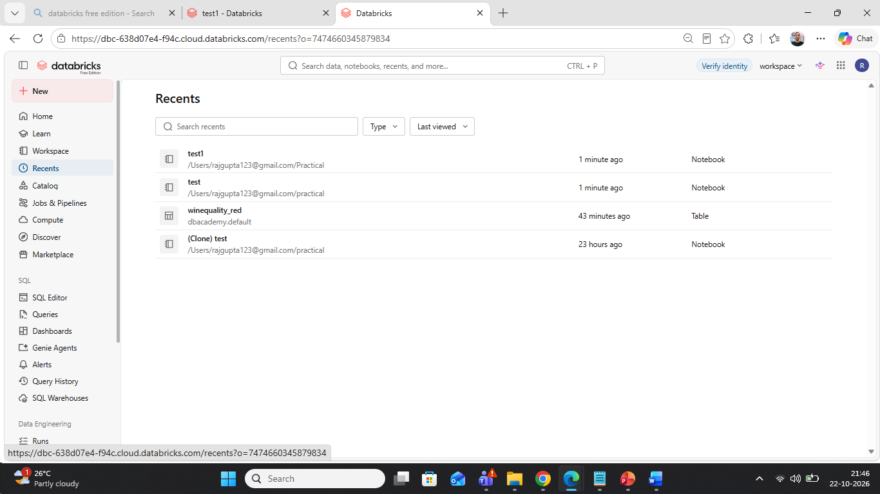
Below workspace ,
Recent :-we have recent :- what ever we have to do any activity we have to find out inside the recent
Catalog:-This is unity catalog ->you can see all your data and manage your data ,whatever access control you have to do it using Unity catalog .
Job and Pipeline:-If you want to schedule the job daily and monthly basis create the jobs from here and you can schedule the job daily ,monthly basis .
Compute - SQL warehouses:- we have server less compute,that can we use in your notebook that execute your code
SQL:- we have Sql Editor
You have to write any type of sql code:-
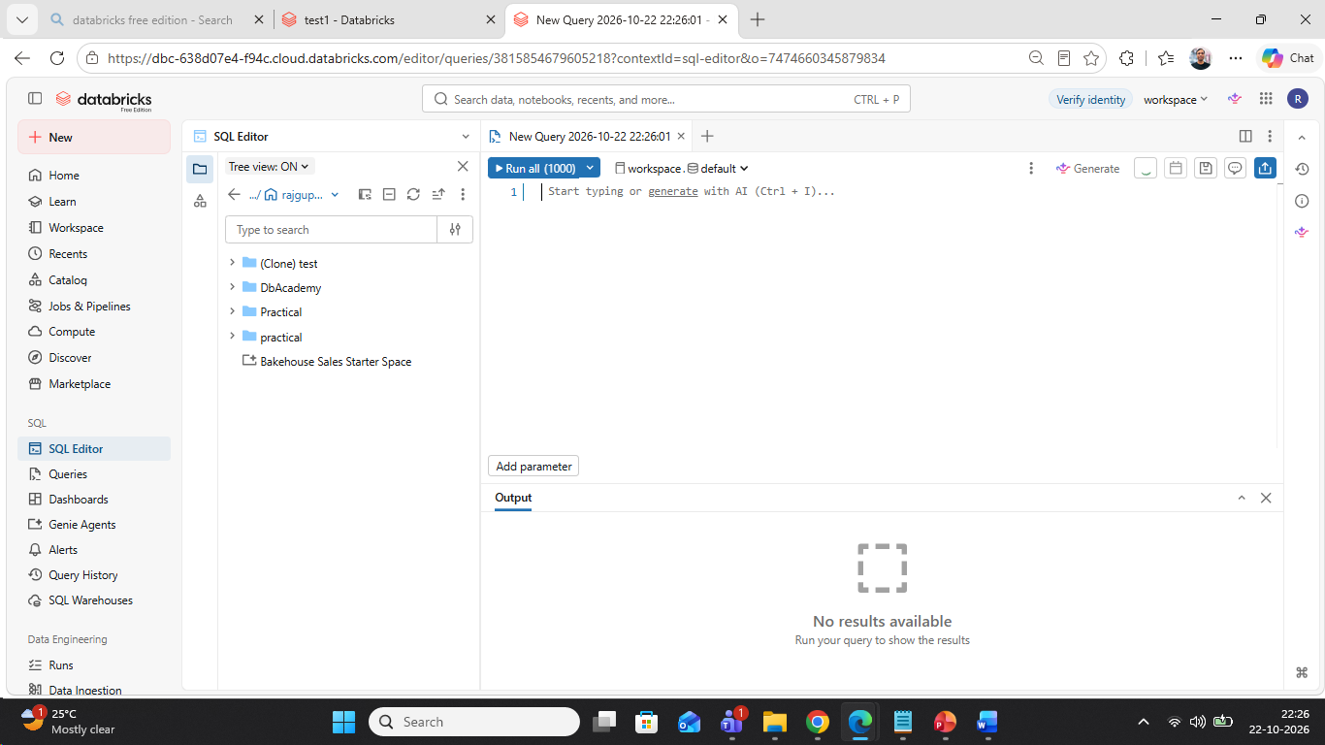
Query:- whatever you’re the query in sql editor you can find out in the Query
Dashboard:-Create any kind of Dashboard
Genie :- Genie is the AI tool ,where you can explore your data.just like Chat GPT
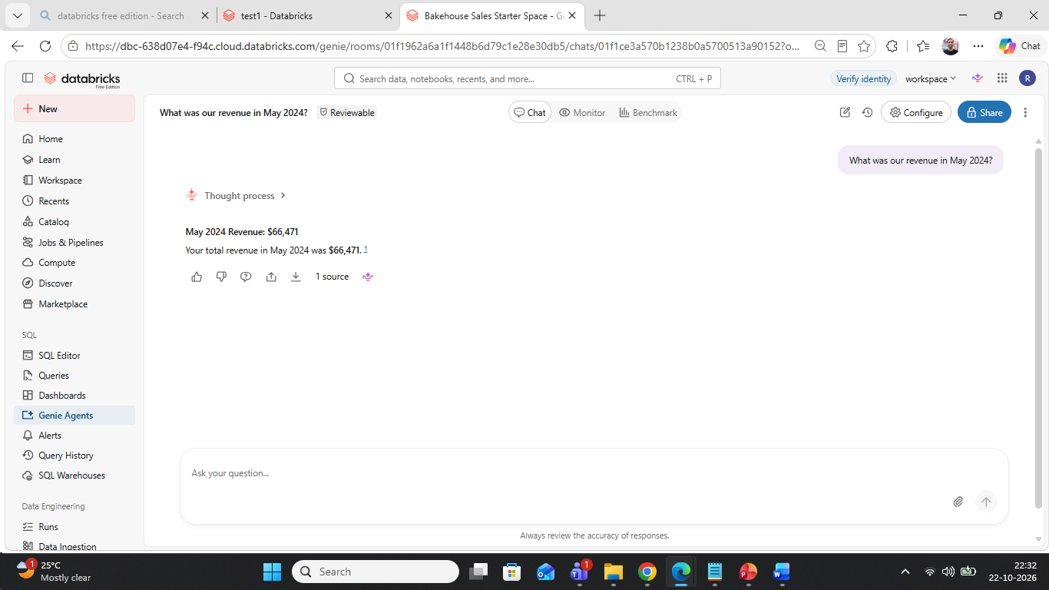
show me sales customer table
Data Engineering :-
Unity catalog:- having 3 level namespace for all the assets.
- 1st created the catalog
- 2nd is DB(database)--schema
- 3rd is the table

1. Unity Catalog structure
Metastore
└── Catalog
└── Schema
└── Table / View / Function / Volume

For querying a table, you normally use the three-level namespace:
catalog.schema.table
Databricks documentation confirms that a Catalog contains Schemas, and a Schema contains objects such as tables, views, functions, and volumes.

2. Compare this with SQL Server
Server
└── Database
└── Schema
└── Table

SQLServer01
└── SalesDB
└── dbo
└── Customer
Inside SQL Server, you commonly query:
SELECT *
FROM SalesDB.dbo.Customer;
Side-by-side comparison
Traditional SQL Server | Databricks Unity Catalog
Server | Metastore / Databricks environment
Database | Catalog
Schema | Schema
Table | Table
SalesDB.dbo.Customer | sales.dbo.customer

So for someone coming from SQL Server, a very useful mental model is:
Databricks Catalog ≈ SQL Server Database
and
Databricks Schema ≈ SQL Server Schema

